Data Flow Diagrams:

Project Design Phase-II
Data Flow Diagram & User Stories

Date | 13 July 2026
Team ID
Project Name | DarshanEase
Maximum Marks | 4 Marks

A Data Flow Diagram (DFD) is a traditional visual representation of the information flows within a system. A neat and clear DFD can depict the right amount of the system requirement graphically. It shows how data enters and leaves the system, what changes the information, and where data is stored.

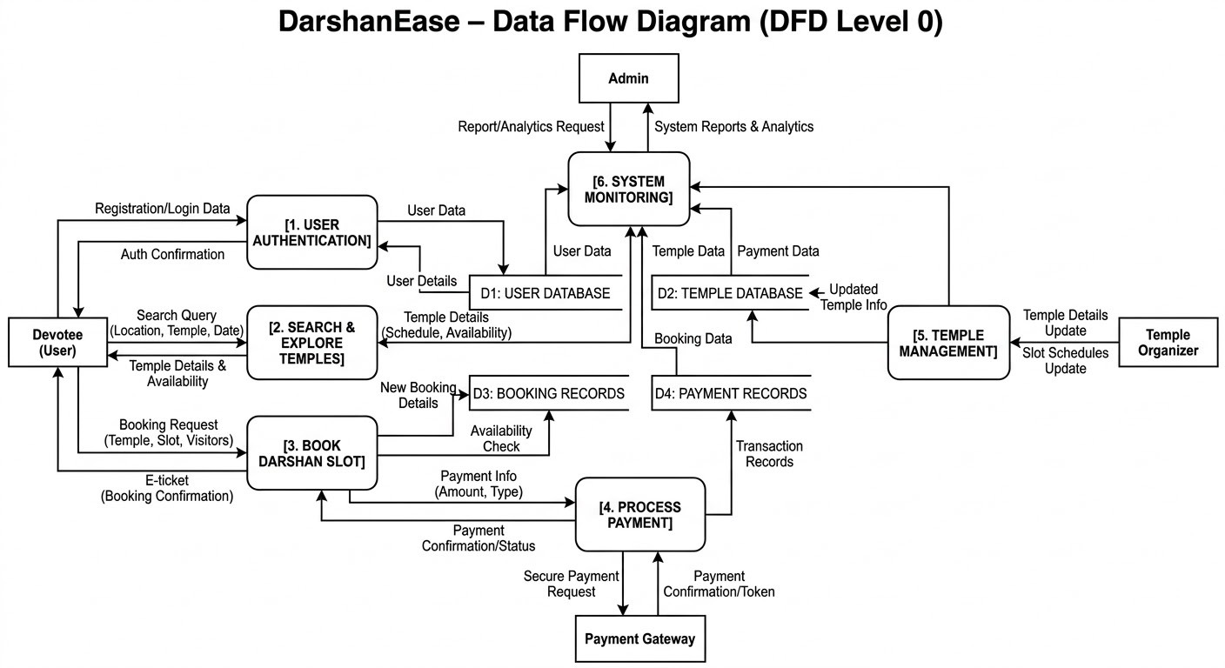

User Stories
Use the below template to list all the user stories for the product.

User Type | Functional Requirement  (Epic) | User Story Number | User Story / Task | Acceptance criteria | Priority | Release
Customer (Mobile user) | Registration | USN-1 | As a user, I can register using email and password to create an account | User account is created  and dashboard is accessible | High | Sprint-1
Customer  (Mobile user) | Login | USN-2 | As a user, I can log into the application  using my email and password | User can access  dashboard after login | High | Sprint-1
Customer  (Mobile user) | Temple Search | USN-3 | As a user, I can search temples by  location or name | System displays list of  temples | High | Sprint-1
Customer (Mobile user) | Darshan Booking | USN-4 | As a user, I can book a Darshan slot for a selected temple | Slot is reserved and confirmation is  generated | High | Sprint-2
Customer  (Mobile user) | Online Donation | USN-5 | As a user, I can donate securely to  temples online | Payment is processed  and receipt generated | Medium | Sprint-2
Customer  (Mobile user) | Booking History | USN-6 | As a user, I can view my previous  bookings | User can see booking  details | Medium | Sprint-3
Temple  Organizer | Temple  Management | USN-7 | As an organizer, I can manage temple  details and schedules | Organizer can update temple information | High | Sprint-2
Admin | System Monitoring | USN-8 | As an admin, I can monitor users, bookings, and donations | Admin dashboard displays analytics | High | Sprint-3

